**Front-End UI/UX Mini Project**

**Project Title:** Movie Info Page

**Submitted by:**

* **Team members:** Thirisha Babu Velu

Aishwarya S

Tharika K

* **Roll Number:** 2460464

2460315

2460463

* **College E-mail id:** thirisha.babu@btech.christuniversity.in

aishwarya.s@btech.christuniversity.in

tharika.k@btech.christuniversity.in

**Course:** Front-End UI/UX Development

**Instructor Name:** Mr. Narendran

**Institution:** Christ University

**Date of Submission:**11.08.2025

**2.Abstract:**

* This project aims to design and develop a simple and responsive movie information page for the film ‘Cinderella’using only HTML and CSS.
* The main goal is to present key movie details like the title, synopsis, cast, release date, and poster in a clean and visually appealing layout. The project focuses on creating a user-friendly design that adapts well to different screen sizes.
* Core technologies used include HTML for structure and CSS for styling and layout.
* The final outcome is a static movie info webpage that serves as a basic example of how HTML and CSS can be used to create attractive and informative pages without the need for JavaScript or backend technologies.

**3.Objectives:**

* Design a clear and attractive layout to display movie details using HTML and CSS.
* Create a fully responsive design that works well on desktops, tablets, and mobile devices.
* Apply basic UI principles to enhance readability and user experience.
* Showcase core HTML and CSS skills in a simple, focused project.

**4.Scope of the Project:**

* Focused on front-end design only.
* No JavaScript or backend/server-side programming involved.
* Designed to work on desktop, tablet, and mobile devices.
* Used only HTML and CSS — no external libraries or frameworks.
* Only includes one movie page (Cinderella) with basic details and layout.

**5.Tools & Technologies Used:**

|  |  |
| --- | --- |
| **Tool/Technology** | **Purpose** |
| HTML5 | For creating the structure and content of the webpage |
| CSS3 | For creating the structure and content of the webpage |
| VS Code | As the code editor to write and manage code |
| Chrome DevTools | For testing responsiveness and debugging styles |

**6.HTML Structure Overview:**

* Used semantic tags: <header>, <nav>, <main>, <section>, <footer>.
* <header>: Displays the movie title (Cinderella) at the top of the page.
* <nav>: Contains navigation links to jump to sections like About, Cast, and Details.
* <main>: Holds all the main content related to the movie.
* <section>: Divides content into parts such as About the Movie, Cast, and Movie Details.
* <footer>: Shown at the bottom of the page, includes copyright information.

**7.CSS Styling Strategy:**

* Used external CSS file (style.css).
* CSS code is organized with proper comments and grouped into sections.
* Techniques used:

1. Flexbox for aligning the movie image and details side by side.
2. Media Queries to make the layout responsive on smaller screens.

* Additional styling features:

1. CSS Variables for easy color and font customization.
2. Hover effects for links and buttons to improve interactivity.
3. Mobile-first design approach to ensure good performance on phones and tablets.

**8.Key Features:**

|  |  |
| --- | --- |
| **Feature** | **Description** |
| Responsive Layout | Adjusts well to desktop, tablet, and mobile screens |
| Movie Poster Display | Shows the Cinderella poster using <img> with responsive sizing |
| Structured Info Sections | Content divided into About, Cast, and Details using semantic tags |
| Clean Visual Design | Simple layout with clear fonts and spacing for easy reading |

**9.Challenges Faced & Solutions:**

|  |  |
| --- | --- |
| **Challenges** | **Solution** |
| Elements breaking on smaller screens | Used media queries to make layout flexible and responsive |
| Uneven spacing between sections | Applied consistent margins and padding using CSS |
| Image not resizing properly | Set max-width: 300px and height: auto for responsive image scaling |

**10.Outcome:**

* Created a simple and visually appealing movie info page using only HTML and CSS.
* Displayed key movie details like poster, story, cast, and release info in a clean layout.
* Improved understanding of responsive design, layout techniques and semantic HTML.

**11.Future Enhancements:**

* Add JavaScript for dynamic features like trailer popup or show/hide cast list.
* Include animations or transitions for smoother visual effects.
* Add a search bar to look up other movies.
* Implement a theme switcher (dark/light mode) for better user experience.

**12.Sample Code:**

**//index.html**

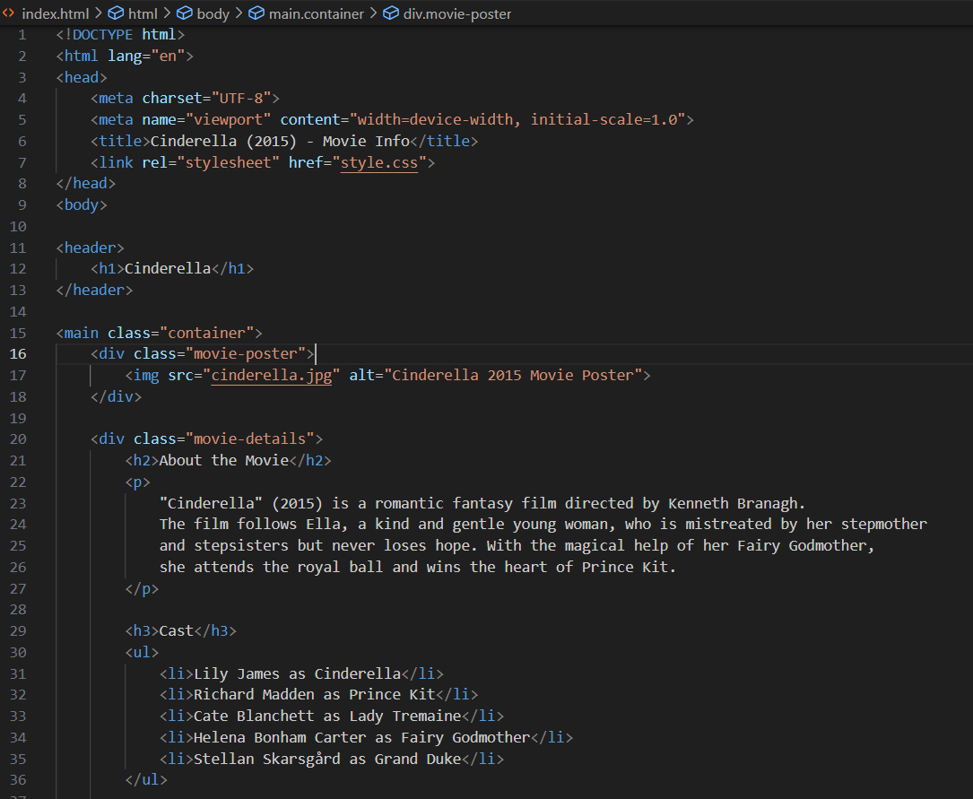

**//style.css**

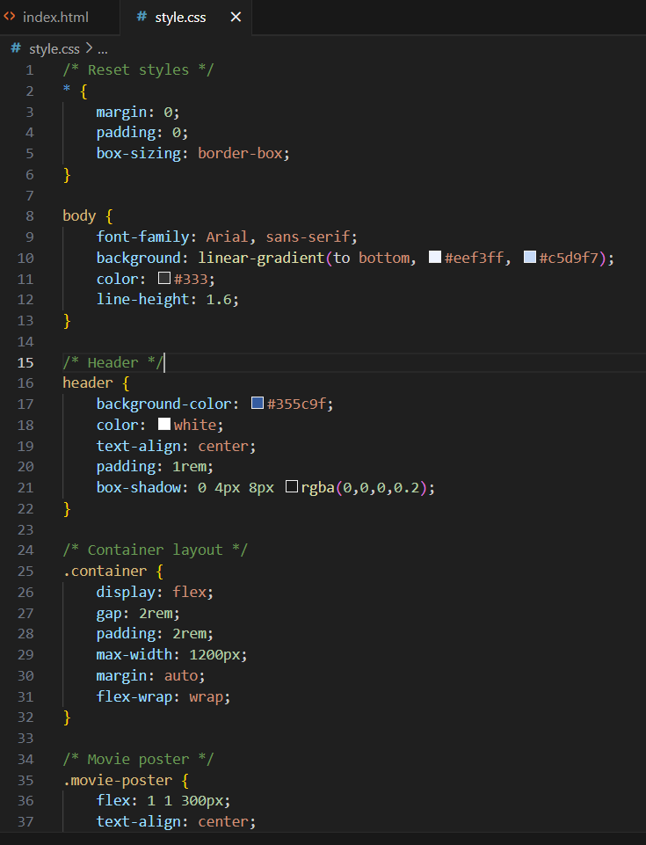

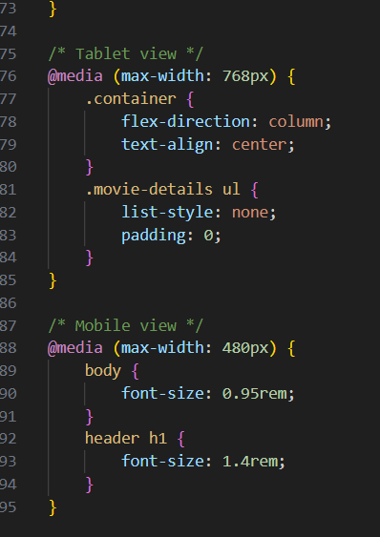

**13.Screenshots of Final Output:**

* Output as seen on laptop

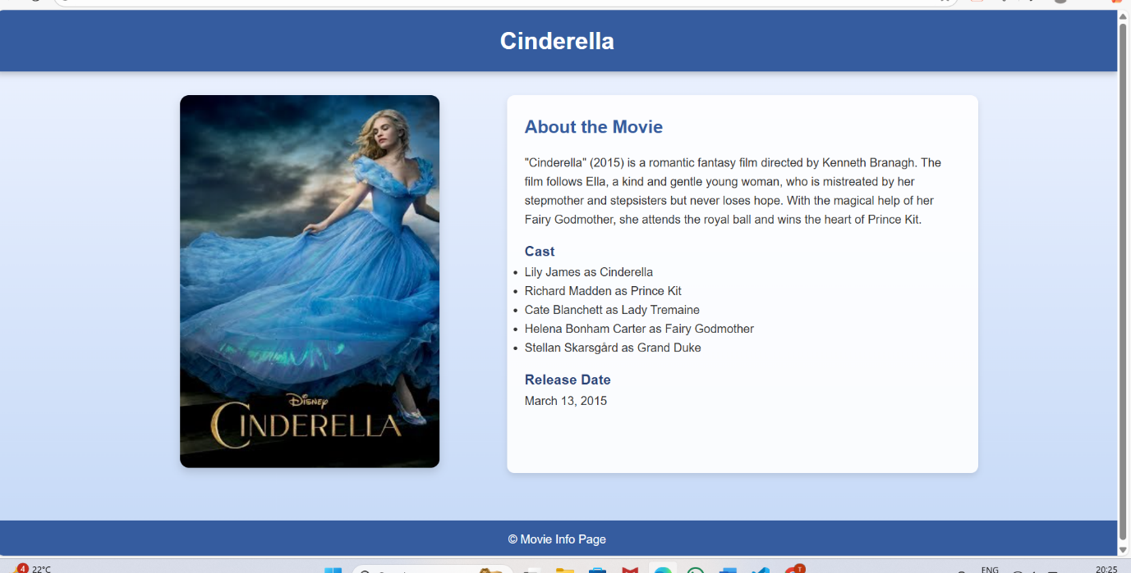

* Output as seen on mobile phone

**14.Conclusion:**

* In this project, we created a movie info page using HTML and CSS. HTML was used to structure the content, such as the movie title, poster, description, cast, and other details. CSS was used to style the page and make it visually appealing, including colors, fonts, layout, and spacing.
* This mini project helped us understand how to combine HTML and CSS to build a clean and attractive web page. It also improved our skills in designing user-friendly interfaces for displaying information.

**15.References:**

* L&T LMS: https://learn.lntedutech.com/Landing/MyCourse